**SSN College of Engineering, Kalavakkam**

**Department of Computer Science and Engineering**

**UCS1711-Mobile Application Development Lab**

**Exercise 1**: **Personal Information Page using GUI Controls, Fonts and Colors**

**Name : S.NACHAMMAI DEVI POOJA**

**Class :CSE Sec: B**

**Reg no: 185001096**

**AIM:**

To develop an android application using GUI controls for creating personal information page with the specifications given.

**CODE:**

activity_main.xml :

<?xml version="1.0" encoding="utf-8"?>  
<androidx.constraintlayout.widget.ConstraintLayout xmlns:android="http://schemas.android.com/apk/res/android"  
 xmlns:app="http://schemas.android.com/apk/res-auto"  
 xmlns:tools="http://schemas.android.com/tools"  
 android:layout_width="match_parent"  
 android:layout_height="match_parent"  
 tools:context=".MainActivity">  
  
 <TextView  
 android:id="@+id/textView6"  
 android:layout_width="wrap_content"  
 android:layout_height="wrap_content"  
 android:text="Name :"  
 android:textColor="#3F51B5"  
 android:textSize="18sp"  
 app:layout_constraintBottom_toBottomOf="parent"  
 app:layout_constraintEnd_toEndOf="parent"  
 app:layout_constraintHorizontal_bias="0.177"  
 app:layout_constraintStart_toStartOf="parent"  
 app:layout_constraintTop_toTopOf="parent"  
 app:layout_constraintVertical_bias="0.152" />  
  
 <EditText  
 android:id="@+id/editTextTextPersonName3"  
 android:layout_width="202dp"  
 android:layout_height="40dp"  
 android:ems="10"  
 android:inputType="textPersonName"  
 android:textSize="16sp"  
 app:layout_constraintBottom_toBottomOf="parent"  
 app:layout_constraintEnd_toEndOf="parent"  
 app:layout_constraintHorizontal_bias="0.832"  
 app:layout_constraintStart_toStartOf="parent"  
 app:layout_constraintTop_toTopOf="parent"  
 app:layout_constraintVertical_bias="0.131" />  
  
 <TextView  
 android:id="@+id/textView7"  
 android:layout_width="wrap_content"  
 android:layout_height="wrap_content"  
 android:text="Please fill your details below:"  
 android:textAppearance="@style/TextAppearance.AppCompat.Body2"  
 android:textColor="#3F51B5"  
 android:textSize="20sp"  
 app:layout_constraintBottom_toBottomOf="parent"  
 app:layout_constraintEnd_toEndOf="parent"  
 app:layout_constraintHorizontal_bias="0.498"  
 app:layout_constraintStart_toStartOf="parent"  
 app:layout_constraintTop_toTopOf="parent"  
 app:layout_constraintVertical_bias="0.054" />  
  
 <TextView  
 android:id="@+id/textView8"  
 android:layout_width="wrap_content"  
 android:layout_height="wrap_content"  
 android:text="DOB :"  
 android:textColor="#3F51B5"  
 android:textSize="18sp"  
 app:layout_constraintBottom_toBottomOf="parent"  
 app:layout_constraintEnd_toEndOf="parent"  
 app:layout_constraintHorizontal_bias="0.164"  
 app:layout_constraintStart_toStartOf="parent"  
 app:layout_constraintTop_toTopOf="parent"  
 app:layout_constraintVertical_bias="0.228" />  
  
 <TextView  
 android:id="@+id/textView9"  
 android:layout_width="wrap_content"  
 android:layout_height="wrap_content"  
 android:text="Address"  
 android:textColor="#3F51B5"  
 android:textSize="18sp"  
 app:layout_constraintBottom_toBottomOf="parent"  
 app:layout_constraintEnd_toEndOf="parent"  
 app:layout_constraintHorizontal_bias="0.175"  
 app:layout_constraintStart_toStartOf="parent"  
 app:layout_constraintTop_toTopOf="parent"  
 app:layout_constraintVertical_bias="0.304" />  
  
 <TextView  
 android:id="@+id/textView10"  
 android:layout_width="wrap_content"  
 android:layout_height="wrap_content"  
 android:text="Email :"  
 android:textColor="#3F51B5"  
 android:textSize="18sp"  
 app:layout_constraintBottom_toBottomOf="parent"  
 app:layout_constraintEnd_toEndOf="parent"  
 app:layout_constraintHorizontal_bias="0.167"  
 app:layout_constraintStart_toStartOf="parent"  
 app:layout_constraintTop_toTopOf="parent"  
 app:layout_constraintVertical_bias="0.396" />  
  
 <TextView  
 android:id="@+id/textView11"  
 android:layout_width="wrap_content"  
 android:layout_height="wrap_content"  
 android:text="Ph Number :"  
 android:textColor="#3F51B5"  
 android:textSize="18sp"  
 app:layout_constraintBottom_toBottomOf="parent"  
 app:layout_constraintEnd_toEndOf="parent"  
 app:layout_constraintHorizontal_bias="0.169"  
 app:layout_constraintStart_toStartOf="parent"  
 app:layout_constraintTop_toTopOf="parent"  
 app:layout_constraintVertical_bias="0.481" />  
  
 <TextView  
 android:id="@+id/textView12"  
 android:layout_width="wrap_content"  
 android:layout_height="wrap_content"  
 android:text="Gender :"  
 android:textColor="#3F51B5"  
 android:textSize="18sp"  
 app:layout_constraintBottom_toBottomOf="parent"  
 app:layout_constraintEnd_toEndOf="parent"  
 app:layout_constraintHorizontal_bias="0.172"  
 app:layout_constraintStart_toStartOf="parent"  
 app:layout_constraintTop_toTopOf="parent"  
 app:layout_constraintVertical_bias="0.561" />  
  
 <TextView  
 android:id="@+id/textView13"  
 android:layout_width="wrap_content"  
 android:layout_height="wrap_content"  
 android:text="Languages Known :"  
 android:textColor="#3F51B5"  
 android:textSize="18sp"  
 app:layout_constraintBottom_toBottomOf="parent"  
 app:layout_constraintEnd_toEndOf="parent"  
 app:layout_constraintHorizontal_bias="0.185"  
 app:layout_constraintStart_toStartOf="parent"  
 app:layout_constraintTop_toTopOf="parent"  
 app:layout_constraintVertical_bias="0.748" />  
  
 <RadioButton  
 android:id="@+id/radioButton"  
 android:layout_width="wrap_content"  
 android:layout_height="wrap_content"  
 android:text="Male"  
 android:textSize="16sp"  
 android:textStyle="italic"  
 app:layout_constraintBottom_toBottomOf="parent"  
 app:layout_constraintEnd_toEndOf="parent"  
 app:layout_constraintHorizontal_bias="0.163"  
 app:layout_constraintStart_toStartOf="parent"  
 app:layout_constraintTop_toTopOf="parent"  
 app:layout_constraintVertical_bias="0.67" />  
  
 <RadioButton  
 android:id="@+id/radioButton2"  
 android:layout_width="wrap_content"  
 android:layout_height="wrap_content"  
 android:text="Female"  
 android:textSize="16sp"  
 android:textStyle="italic"  
 app:layout_constraintBottom_toBottomOf="parent"  
 app:layout_constraintEnd_toEndOf="parent"  
 app:layout_constraintHorizontal_bias="0.489"  
 app:layout_constraintStart_toStartOf="parent"  
 app:layout_constraintTop_toTopOf="parent"  
 app:layout_constraintVertical_bias="0.67" />  
  
 <RadioButton  
 android:id="@+id/radioButton3"  
 android:layout_width="wrap_content"  
 android:layout_height="wrap_content"  
 android:text="Others"  
 android:textSize="16sp"  
 android:textStyle="italic"  
 app:layout_constraintBottom_toBottomOf="parent"  
 app:layout_constraintEnd_toEndOf="parent"  
 app:layout_constraintHorizontal_bias="0.839"  
 app:layout_constraintStart_toStartOf="parent"  
 app:layout_constraintTop_toTopOf="parent"  
 app:layout_constraintVertical_bias="0.67" />  
  
 <CheckBox  
 android:id="@+id/checkBox"  
 android:layout_width="wrap_content"  
 android:layout_height="wrap_content"  
 android:text="English"  
 android:textSize="16sp"  
 android:textStyle="italic"  
 app:layout_constraintBottom_toBottomOf="parent"  
 app:layout_constraintEnd_toEndOf="parent"  
 app:layout_constraintHorizontal_bias="0.173"  
 app:layout_constraintStart_toStartOf="parent"  
 app:layout_constraintTop_toTopOf="parent"  
 app:layout_constraintVertical_bias="0.852" />  
  
 <CheckBox  
 android:id="@+id/checkBox2"  
 android:layout_width="wrap_content"  
 android:layout_height="wrap_content"  
 android:text="Tamil"  
 android:textSize="16sp"  
 android:textStyle="italic"  
 app:layout_constraintBottom_toBottomOf="parent"  
 app:layout_constraintEnd_toEndOf="parent"  
 app:layout_constraintHorizontal_bias="0.507"  
 app:layout_constraintStart_toStartOf="parent"  
 app:layout_constraintTop_toTopOf="parent"  
 app:layout_constraintVertical_bias="0.852" />  
  
 <CheckBox  
 android:id="@+id/checkBox3"  
 android:layout_width="wrap_content"  
 android:layout_height="wrap_content"  
 android:text="Telugu"  
 android:textSize="16sp"  
 android:textStyle="italic"  
 app:layout_constraintBottom_toBottomOf="parent"  
 app:layout_constraintEnd_toEndOf="parent"  
 app:layout_constraintHorizontal_bias="0.173"  
 app:layout_constraintStart_toStartOf="parent"  
 app:layout_constraintTop_toTopOf="parent"  
 app:layout_constraintVertical_bias="0.947" />  
  
 <CheckBox  
 android:id="@+id/checkBox5"  
 android:layout_width="wrap_content"  
 android:layout_height="wrap_content"  
 android:text="Hindi"  
 android:textSize="16sp"  
 android:textStyle="italic"  
 app:layout_constraintBottom_toBottomOf="parent"  
 app:layout_constraintEnd_toEndOf="parent"  
 app:layout_constraintHorizontal_bias="0.498"  
 app:layout_constraintStart_toStartOf="parent"  
 app:layout_constraintTop_toTopOf="parent"  
 app:layout_constraintVertical_bias="0.947" />  
  
 <CheckBox  
 android:id="@+id/checkBox6"  
 android:layout_width="wrap_content"  
 android:layout_height="wrap_content"  
 android:text="Kannada"  
 android:textSize="16sp"  
 android:textStyle="italic"  
 app:layout_constraintBottom_toBottomOf="parent"  
 app:layout_constraintEnd_toEndOf="parent"  
 app:layout_constraintHorizontal_bias="0.87"  
 app:layout_constraintStart_toStartOf="parent"  
 app:layout_constraintTop_toTopOf="parent"  
 app:layout_constraintVertical_bias="0.852" />  
  
 <EditText  
 android:id="@+id/editTextDate"  
 android:layout_width="wrap_content"  
 android:layout_height="wrap_content"  
 android:ems="10"  
 android:inputType="date"  
 app:layout_constraintBottom_toBottomOf="parent"  
 app:layout_constraintEnd_toEndOf="parent"  
 app:layout_constraintHorizontal_bias="0.865"  
 app:layout_constraintStart_toStartOf="parent"  
 app:layout_constraintTop_toTopOf="parent"  
 app:layout_constraintVertical_bias="0.214" />  
  
 <EditText  
 android:id="@+id/editTextTextPostalAddress"  
 android:layout_width="wrap_content"  
 android:layout_height="wrap_content"  
 android:ems="10"  
 android:inputType="textPostalAddress"  
 app:layout_constraintBottom_toBottomOf="parent"  
 app:layout_constraintEnd_toEndOf="parent"  
 app:layout_constraintHorizontal_bias="0.86"  
 app:layout_constraintStart_toStartOf="parent"  
 app:layout_constraintTop_toTopOf="parent"  
 app:layout_constraintVertical_bias="0.29" />  
  
 <EditText  
 android:id="@+id/editTextTextEmailAddress"  
 android:layout_width="wrap_content"  
 android:layout_height="wrap_content"  
 android:ems="10"  
 android:inputType="textEmailAddress"  
 app:layout_constraintBottom_toBottomOf="parent"  
 app:layout_constraintEnd_toEndOf="parent"  
 app:layout_constraintHorizontal_bias="0.86"  
 app:layout_constraintStart_toStartOf="parent"  
 app:layout_constraintTop_toTopOf="parent"  
 app:layout_constraintVertical_bias="0.377" />  
  
 <EditText  
 android:id="@+id/editTextNumber"  
 android:layout_width="wrap_content"  
 android:layout_height="wrap_content"  
 android:ems="10"  
 android:inputType="number"  
 app:layout_constraintBottom_toBottomOf="parent"  
 app:layout_constraintEnd_toEndOf="parent"  
 app:layout_constraintHorizontal_bias="0.85"  
 app:layout_constraintStart_toStartOf="parent"  
 app:layout_constraintTop_toTopOf="parent"  
 app:layout_constraintVertical_bias="0.482" />  
  
</androidx.constraintlayout.widget.ConstraintLayout>

**Output Screenshot:**

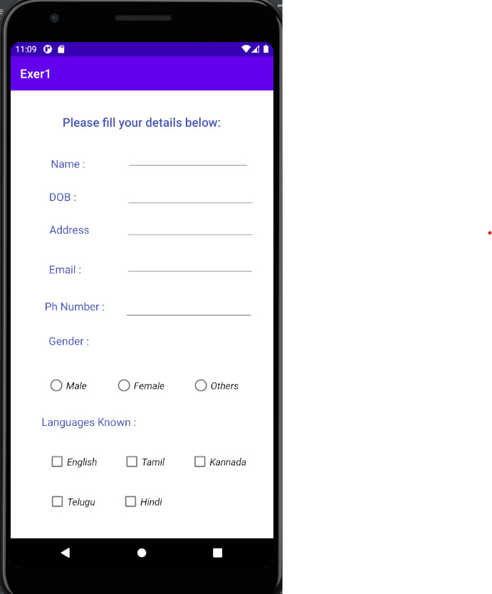

After entering values:

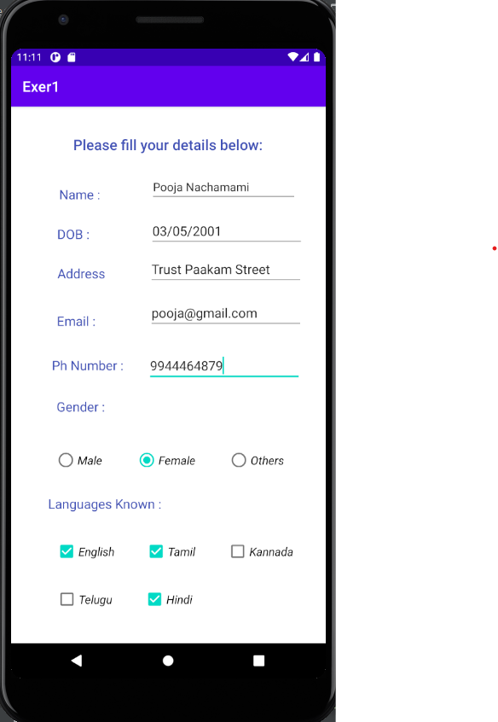

**Result:**

An android application using GUI controls for creating personal information page has been created with the specified formatting.